

Programming lab Home Task

Name Hasnain Ali

Reg. No 478806
Section C

Home task No:1

#include<iostream>
using namespace std;
int main()
{
//program thats print the number from 1 to 10
//but not multiple of 10.
int a;
for(a=1; a<=150; ++a)
{
if( a%10 !=0)
{
cout<<a<<endl;
}

}
return 0;
}
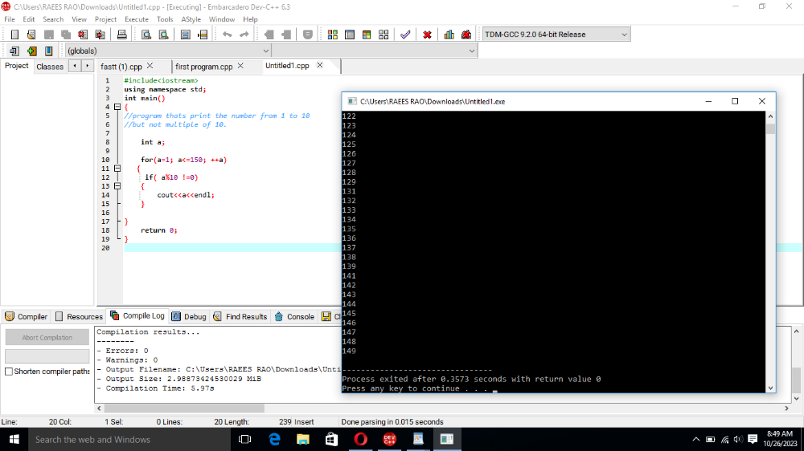

Home task No:2

#include<iostream>
using namespace std;
int main()
{
//program to find the sum of
//digits of given number
int num;//given number
int sum=0;
cout<<"Enter the number num whose sum of digit is to be found:"<<endl;
cin>>num;
while(num!=0)
{

sum=sum+num%10;
num=int(num/10);

}

cout<<"the sum of digit of given num is:"<<sum<<endl; // for sum of digits
return 0;
}
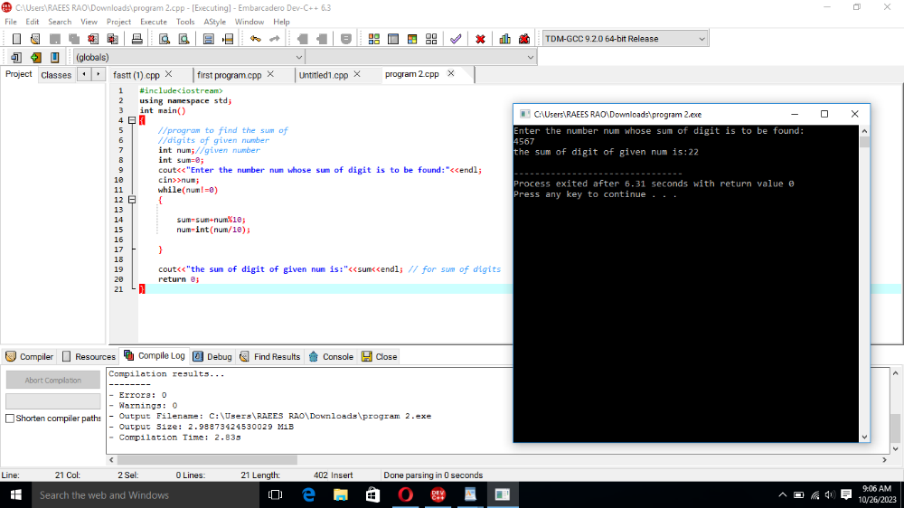
Home task No:3
#include<iostream>
using namespace std;
int main()
{//program to check that whether a
//given number is prime or noy

int i;
int num;
cout<<"Enter the value of given number:";
cin>>num;//for input
i=2;
while(i<num)

{
if(num%i==0)//multiple between 1 and given num
{
cout<<"The given number is not prime number"<<endl;
break;
}
i++;
}if(i==num){
cout<<"the given number is prime number"<<endl;//otherwise it is a ptrime number
}return 0;

}
